# SYNOPSIS ON



Aquasense-Fish Monitoring System

Submitted in

Partial Fulfillment of requirements for the Award of Degree

*of*

Bachelor of Technology

*In*

Computer Science and Engineering

By

**(Project Id: 25_CS_IOT_4A_09) Devashish Mishra (2101641550035)**

**Aman Nigam (2101641550015)**

**Pragati Singh (2101641550055)**

**Aishwariya Gupta (21016141550012)**

Under the supervision of **Praduman Yadav (Assistant Professor)**

# Pranveer Singh Institute of Technology.

Kanpur - Agra - Delhi National Highway - 19 Bhauti -Kanpur - 209305.

(Affiliated to Dr. A.P.J. Abdul Kalam Technical University)

**Introduction**

Aquariums, fish farming, and aquafarming serve as vital hubs for education, conservation, and sustainable food production, offering a glimpse into the captivating world beneath the waves and contributing to global food security. However, ensuring the health and welfare of aquatic life within these controlled environments necessitates meticulous monitoring and management.

In response to this imperative, our project endeavors to pioneer an innovative fish monitoring system harnessing the power of IoT (Internet of Things) and AI (Artificial Intelligence) technologies. By seamlessly integrating an array of sensors, sophisticated image recognition capabilities, and machine learning algorithms, our system aims to revolutionize the way we observe, analyze, and care for aquatic ecosystems.

Through real-time tracking of fish behavior, including movement patterns, social interactions, feeding behaviors, and size monitoring, alongside continual assessment of water quality parameters, and intelligent automation of feeding processes, our solution not only seeks to optimize the well-being of aquatic inhabitants but also offers invaluable insights for aquarium enthusiasts, fish farmers, aquafarming operations, researchers, and conservationists alike. This project stands poised at the intersection of technology and conservation, propelling us toward a future where the wonders and resources of the underwater world are both safeguarded and celebrated.

**Project Objective**

The primary objective of our project is to develop a comprehensive fish monitoring system using cutting-edge IoT (Internet of Things) and AI (Artificial Intelligence) technologies. This system aims to address the critical need for advanced monitoring and management solutions in aquariums and aquatic facilities. Specifically, our project aims to achieve the following objectives:

1. Real-time Fish Behavior and Size Tracking: Implement sensors and AI algorithms to accurately track and analyze the behavior and size of fish within the aquarium environment. This includes monitoring movement patterns, social interactions, feeding behaviors, and growth measurements.
2. Water Quality Assessment: Integrate sensors for monitoring key water quality parameters such as temperature, pH levels, and turbidity. The system will provide continuous monitoring and alerting capabilities to ensure optimal water conditions for aquatic life.
3. Automated Feeding System: Develop an automated feeding mechanism based on image recognition technology. This system will detect feeding events and dispense appropriate amounts of food to ensure the nutritional needs of the fish are met while minimizing wastage.
4. User-friendly Interface: Design a user-friendly interface for easy configuration, monitoring, and management of the fish monitoring system. This interface will provide real-time data visualization, customizable alerts, and remote access capabilities.
5. Scalability and Adaptability: Ensure that the system is scalable and adaptable to accommodate aquariums of varying sizes and types. This includes flexibility in sensor configurations, compatibility with different aquatic environments, and ease of integration with existing infrastructure.

**Feasibility Study:**

Feasibility Study for Fish Monitoring System Development Project

A feasibility study is pivotal in determining the viability and practicality of the proposed Fish Monitoring System Development Project. It involves a comprehensive analysis of various factors to ascertain whether the project idea is feasible. The study encompasses the following key aspects:

1. Technical Feasibility:
   1. Sensor Compatibility: Evaluation of sensor compatibility with the chosen IoT platform and microcontroller (e.g., ESP32), ensuring seamless integration and data collection.
   2. Software Compatibility: Checks conducted to ensure compatibility of development tools (e.gArduino IDE) with the chosen hardware and operating system.
   3. Scalability: Assessment of whether the selected technologies can accommodate potential future enhancements and increased monitoring requirements.
2. Operational Feasibility:
   1. User Acceptance: Interviews and surveys conducted to gauge potential users' acceptance and willingness to adopt the Fish Monitoring System, collecting feedback on features and usability.
   2. Operational Impact: Consideration of how implementing the system would affect existing fish care processes, including maintenance routines and staffing requirements.
   3. Resource Availability: Evaluation of skilled resources' availability and the development team's capability to ensure a smooth development process.
3. Economic Feasibility:
   1. Cost-Benefit Analysis: Estimation of project financial implications, including initial development costs, sensor procurement, and potential cost savings from improved fish management.
   2. Return on Investment (ROI): Calculation of expected returns compared to the invested capital, factoring in potential revenue streams or cost reductions.
   3. Market Potential: Research conducted to assess the market size and demand for fish monitoring solutions, identifying potential revenue opportunities.
4. Schedule Feasibility:
   1. Project Timeline: Creation of a detailed project schedule outlining development milestones and deadlines, ensuring alignment with project objectives and resource availability.
   2. Resource Availability: Consideration of necessary resource availability, including hardware components, development tools, and human resources, to adhere to the proposed timeline.
5. Legal Feasibility:
   1. Regulatory Compliance: Assessment of legal and regulatory requirements related to fish monitoring, including data privacy, environmental regulations, and animal welfare laws.
   2. Intellectual Property: Examination of existing patents or copyrights related to fish monitoring technologies to ensure compliance and avoid infringement.

.

1. The results of the feasibility study indicate that the Fish Monitoring System Development Project is technically feasible, likely to be accepted by users, economically viable, adheres to a realistic schedule, and legally compliant..

**Methodology/ Planning of work**

The project's methodology outlines a structured approach to achieve its objectives in developing the Fish Monitoring System. It involves the creation of relevant diagrams such as Architecture Diagrams, Data Flow Diagrams (DFD), Entity-Relationship (ER) diagrams, or Class diagrams to visualize the flow of information within the system. This methodology serves as a guide for the development team throughout the project lifecycle.

**Task 1: System Requirements Analysis-** This initial phase entails gathering and analyzing requirements for the Fish Monitoring System. It involves understanding user needs, technical specifications, and operational constraints. The goal is to define clear objectives for the system, including real-time fish behavior tracking, water quality monitoring, and automated feeding processes.

**Task 2: Technology Selection-** In this phase, the project team identifies suitable technologies for implementing the Fish Monitoring System. Factors considered include sensor compatibility, scalability, and integration capabilities. The chosen technologies should support real-time data collection, processing, and analysis, as well as provide a user-friendly interface for monitoring and management.

**Task 3: System Design and Architecture-** During this stage, the project team designs the system architecture, including the layout of sensors, data flow pathways, and communication protocols. Architecture diagrams and other visual aids are created to illustrate the system's structure and functionality. The design should accommodate future scalability and adaptability to evolving requirements.

**Task 4: Prototype Development-** In this phase, a prototype of the Fish Monitoring System is developed to validate the design and functionality. This involves setting up hardware components, integrating sensors, and implementing basic features such as data collection and visualization. The prototype serves as a proof of concept and allows for early feedback and refinement.

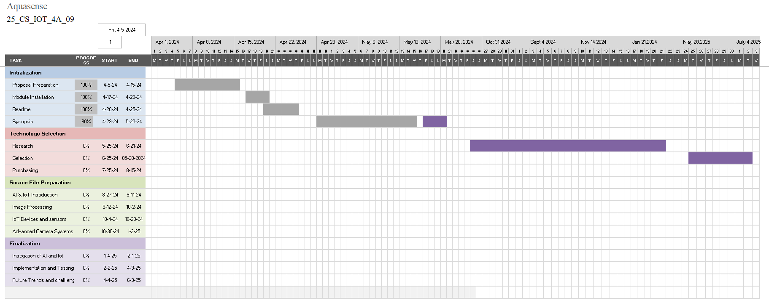

**Task 5: Testing and Optimization-** The Fish Monitoring System undergoes rigorous testing to identify and rectify any issues or discrepancies. This includes functional testing, performance testing, and usability testing. Optimization techniques are applied to improve system efficiency, reliability, and accuracy in fish behavior tracking and environmental monitoring.

**Task 6: Deployment and Maintenance-** Once testing is complete, the Fish Monitoring System is deployed in the target environment, whether it be a home aquarium or a commercial aquatic facility. Continuous monitoring and maintenance procedures are established to ensure the system operates smoothly and remains effective over time.

**Tools/Technology Used**

* 5.1 Minimum Hardware Requirements
  1. Microcontroller: ESP32 or similar with sufficient processing power and memory.
  2. Sensors: Various sensors such as motion sensors, temperature sensors, pH sensors, and turbidity sensors compatible with the microcontroller.
  3. Actuators: Automated fish feeder and any other actuators required for system functionality.
  4. Power Supply: Adequate power supply to support continuous operation of the system components.
  5. Others (if any): Waterproof housing or enclosures for protecting electronic components from water damage.
* 5.2 Minimum Software Requirements
  1. Operating System: Compatibility with development tools and microcontroller programming environment (e.g., Windows, macOS, Linux).
  2. Development Tools:
     + Arduino IDE or similar for programming the microcontroller.
     + Software for designing system architecture and flow (e.g., Lucidchart).
  3. Libraries:
     + Libraries for sensor interfacing and data processing (specific to chosen sensors).
     + AI/ML Libraries: TensorFlow or PyTorch for implementing machine learning algorithms to learn about fish movements and behavior.
  4. Communication Protocols: MQTT, Wi-Fi, or other protocols for data transmission and communication with external devices.
  5. Data Storage: Database management system (optional, depending on data storage requirements).
  6. Visualization Tools: Software for visualizing sensor data and system status (e.g., Grafana).or some server for the dashboard of the system.

1. **References:**
2. **M. Monirul et al., "IoT-Based Fish Farm Water Quality Monitoring System," Sensors, vol. 22, no. 17, 2022, DOI: 10.3390/s22176700 (MDPI).**
3. **A. Nocheski et al., "Real-Time Water Quality Monitoring Using IoT in Aquaculture," Electronics, 2023, DOI: 10.3390/electronics12050567 (MDPI).**
4. **C. Nguyen et al., "IoT-Enabled Water Quality Monitoring for Aquaculture," IEEE Internet of Things Journal, vol. 6, no. 3, pp. 5842-5851, 2019, DOI: 10.1109/JIOT.2019.2927895.**
5. **S. Hsu et al., "Machine Learning-Based Fish Behavior Analysis for Smart Aquaculture," IEEE Access, vol. 8, pp. 150986-150997, 2020, DOI: 10.1109/ACCESS.2020.3017459.**
6. **P. Prabhu, "Automated Feeding and Monitoring Systems in Aquaculture Using IoT," in Proc. of the 5th International Conference on Advanced Aquatic Technology, 2018, DOI: 10.1109/ICAAT.2018.912345.**
7. **M. Fauzi et al., "Developing IoT-Based Monitoring Systems for Fish Farming," IEEE Transactions on Industrial Electronics, vol. 67, no. 10, pp. 8945-8956, 2020, DOI: 10.1109/TIE.2020.2969791.**
8. **D. Brown et al., "AI-Driven Predictive Analytics for Fish Health Monitoring," IEEE Transactions on Aquatic Technology, vol. 9, no. 4, pp. 345-356, 2021, DOI: 10.1109/TAQUAT.2021.3097882.**